National University of Computer and Emerging Sciences



Lab Manual

for

Programming Fundamentals

|  |  |
| --- | --- |
| Course Instructor | Mr. Owais Idrees |
| Lab Instructor(s) | Ms. Abiha Aftab  Ms. Muntaha Zaigham |
| Section | PF J |
| Semester | Fall 2021 |

Department of Computer Science

FAST-NU, Lahore, Pakistan

# INTRODUCTION

## C++ for loop

The syntax of for-loop is:

for (initialization; condition; update) {

// body of-loop

}

Here,

* initialization - initializes variables and is executed only once
* condition - if true, the body of for loop is executed  
  if false, the for loop is terminated
* update - updates the value of initialized variables and again checks the condition

To learn more about conditions, check out our tutorial on [C++ Relational and Logical Operators](https://www.programiz.com/cpp-programming/relational-logical-operators).

## Flowchart of for Loop in C++

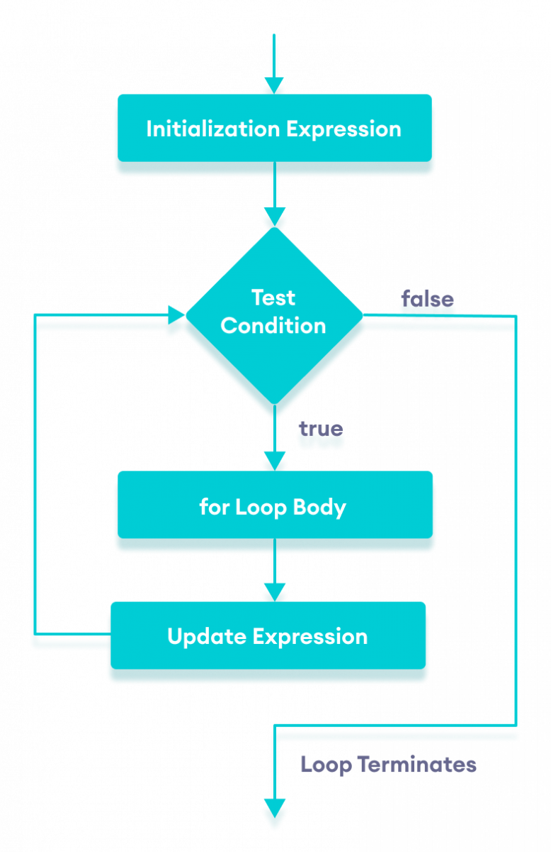Flowchart of for loop in C++

### Example 1: Printing Numbers From 1 to 5

#include <iostream>

using namespace std;

int main() {

for (int i = 1; i <= 5; ++i) {

cout << i << " ";

}

return 0;

}

**Output**

1 2 3 4 5

# Lab Manual 06

**Problem 1:**

## Write a program in C++ that checks if a number entered by the user is Palindrome or not.

## Palindrome: A palindrome is a word, number, phrase, or other sequence of characters which reads the same backward as forward, such as madam or racecar or the number 10201

## For example: 11211 is palindrome 1222 is not a palindrome. 4444 is a palindrome.

## Problem 2 :

## The following C++ code segments can be used to print n spaces or n * on the output device/stream

## Code segment to print spaces

## for(int i = 0; i < n; i++)

## cout<<" ";

## Code Segment to print *

## for(int i = 0; i < n; i++)

## cout<<"* "; Use these code segments within a loop to create programs that can print the following patterns Filled Square of height H The value of H will be given by the user Sample output for H = 8

## * * * * * * * *

## * * * * * * * *

## * * * * * * * *

## * * * * * * * *

## * * * * * * * *

## * * * * * * * *

## * * * * * * * *

## * * * * * * * *

Hollow Square of height H The value of H will be given by the user

Sample output for H = 6

* * * * * *

* *

* *

* *

* *

* * * * * *

Problem 3**:**

Write a C++ program to prints the first n terms of the following Fibonacci series. The value of n is taken as input.

The first 10 terms of the Fibonacci series, i.e.,

for n = 10 are as follows:

1, 1, 2, 3, 5, 8, 13, 21, 34, 55

So the first two terms are 1 and 1 and every successive term is sum of the previous two terms.